

University of Prince Mugrin

College of Computer and Cyber Sciences

Department of Artificial Intelligence

**AI417- Introduction to Deep Learning**

**Course Project – Semester II (Spring 2023)**

Students’ Emotion Detection Model

**Team Members:**

Aisha Ahmad | 4010058

Salwa Shama | 4010405

Samah Shama | 4010403

Sana Shama | 4010404

**Instructor:**

Dr. Ahmed Elhayek

May 22, 2023

**TABLE OF CONTENTS**

**CHAPTER 1: INTRODUCTION** 3

**1.1** **Overview of The Project**  3

**CHAPTER 2: DATASET** 3

**2.1** **Data Description** 3

**3.1** **Developing Plan** 3

**CHAPTER 4: BULID THE MODEL** 4

**CHAPTER 5: ANALYSIS AND DISCUSSION** 5

**5.1** **Successful Design Features and Reasons**  5

**5.2** **Unsuccessful Design Features and Reasons** 5

**5.3** **Additional Design Features and Improvements** 5

**5.4** **Reasons for Applying Some Changes**  5

**5.5** **Change's Reason that Resolved the Issue** 5

**CHAPTER 6: CONCLUSION** 6

**6.1** **Conclusion**  6

**6.2** **References** 6

**APPENDICES** 7

**1.** **Students’ Emotion Detection Code**  7

# **CHAPTER 1:** **INTRODUCTION**

## **1.1 Overview of The Project**

To achieve UPM's objective of providing excellent academic programs and a supportive learning environment for students, a deep learning-based model for emotion detection using face recognition can be designed and developed. This model can help monitor student engagement and emotional responses to learning materials during lectures. Additionally, it can be used for statistical research to analyse student reactions to various activities and events organized by different entities at UPM (e.g., clubs) to rank them based on their positive influence.

Overall, this project will help the instructors gain insights into the effectiveness of their teaching methods and adjust them as needed. In addition, it offers objective measures of emotional responses, allowing for better-informed decision-making regarding future actions. In the end, this will lead to in a more productive and interesting learning environment for UPM students.

# **CHAPTER 2:** **DATASET**

## **2.1 Data Description**

There are many popular data sets on the Web that can be used for facial expression recognition; in our case, we used different kinds of data sets. The first one is FER2013, which contains 28709 examples in the training set and 3589 in the validation set. This dataset divides the emotion into seven feeling expressions: 0 = anger, 1 = disgust, 2 = fear, 3 = happy, 4 = sad, 5 = surprise, and 6 = neutral [1]. The second one is CKPLUS, which contains 981 grayscale training face images and has the same 7 categories of feeling expressions as the FER2013 datasets [2]. Also we used FERPlus the new version of FERP2013, with more quality images and the same number of images, but the difference here is that instead of having 7 categories, we now have 5: 0 = angry, 1 = happy, 2 = neutral, 3 = disgust, and 4 = fear.

**CHAPTER 3:** **DEVELOPMENT MODEL PLAN**

## **3.1 Developing Plan**

AI model building planning is key to ensuring that the developing effort, the spent time, and the consumed resources are well organized. It is also a super important piece of the puzzle for delivering high-accuracy models.

By the way, there is no silver bullet for building models because it tightly depends on the project itself and the dataset. In our project "Students’ Emotion Detection ", we will be following this plan: As we can see, this plan consists of two parts, one related to model components and another related to model architecture. In the first part, we collected the most styles and components that have achieved high accuracy whatever for emotion detection or similar applications. The second part is about CNN architectures that have achieved high accuracy whatever by using the same dataset or a different one.

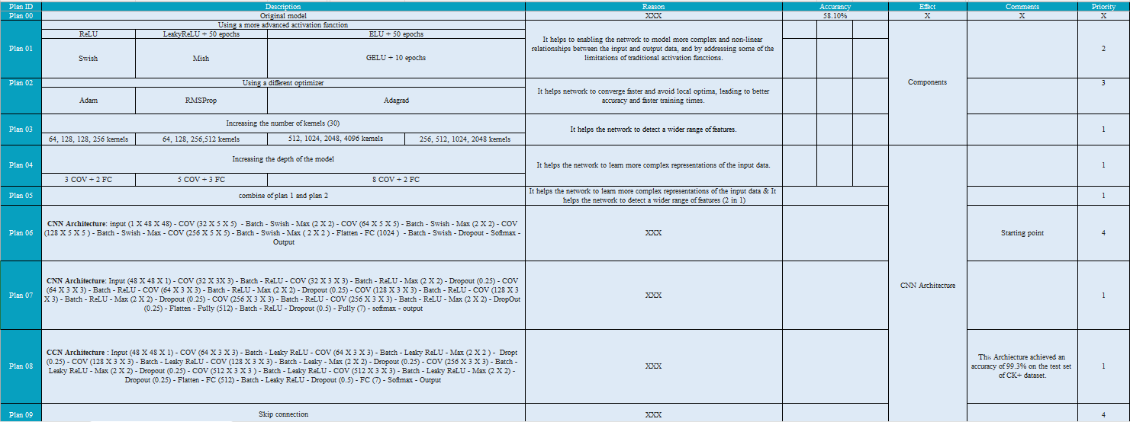

Figure 3.1 – Developing Plan

# **CHAPTER 4: BULID THE MODEL**

Applying our plan to FER 2013, we got the following results: As you can see, unfortunately, the accuracy is not very high. After searching, we found that the highest accuracy that is achieved by this dataset by using CNN is 73.28%, and there is a new version of this dataset called FER2013+ that addresses some issues with FER2013. Even though we had some problems training this data, we played with the CNN architecture, and the highest result we got was 65.1%. For more detail on the training result, visit Chapter 5: Analysis and Discussion [3].

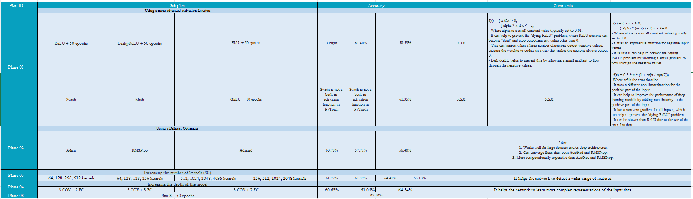

Figure 4.1 – FER2013 Training Results

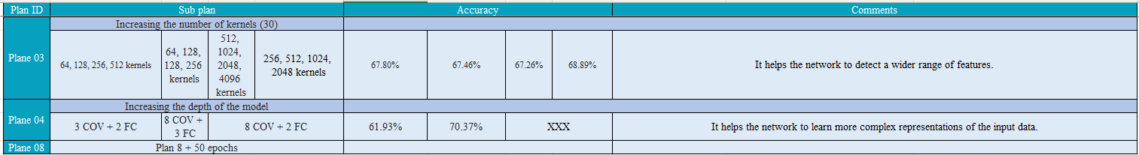

Figure 4.2 – FERPlus Training Results

As we can see in Figure 4.1, yes, not all plans are applied because, at the beginning, we felt there was something wrong and the model accuracy didn't improve a lot, and we figured out the reason that we mentioned earlier. As they say, "You don't need to drink the entire ocean to confirm that it is salty". These few plans were enough for us to discover we had a problem. In terms of FERPlus dataset, the highest result we achieved was 70.37%.

The same plan was applied to the CKPLUS dataset, and as we can see, there are better results in the training, with the highest accuracy being XXX, but honestly, in the testing data, the results are not very good, and that was expected for the small amount of data we trained the model on. For more details on training results, visit Chapter 5: Analysis and Discussion.

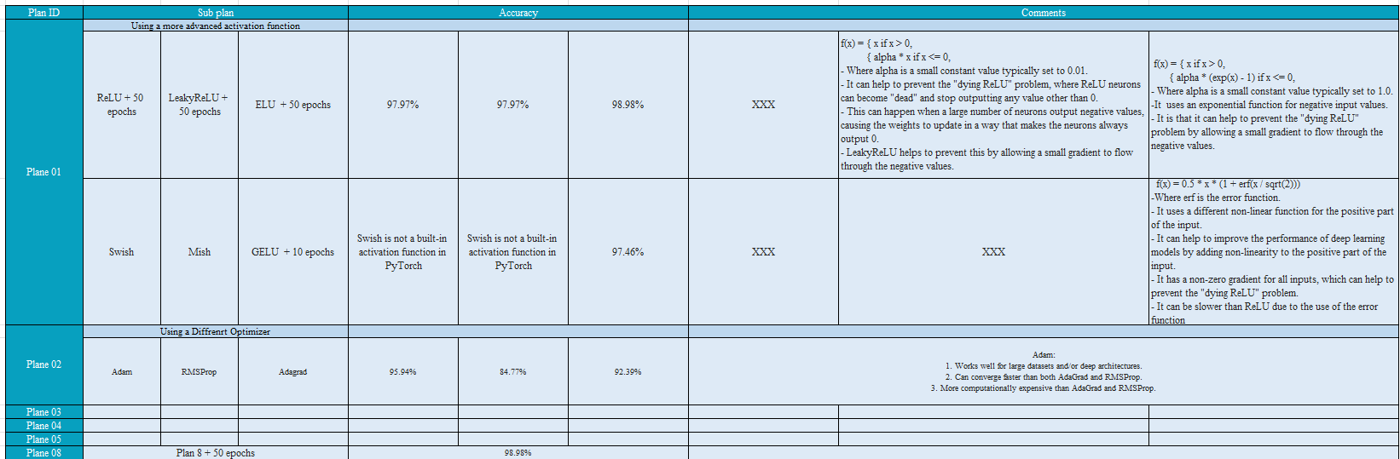

Figure 4.3 – CKPLUS Training Results

Before wrapping up this chapter, it must be mentioned that we tried many architectural model styles with different combinations, and those were just samples.

# **CHAPTER 5:** **ANALYSIS AND DISCUSSION**

This chapter is the thunder of this report. We will discuss what we have learned from this project by going through the following topics: Successful Design Features and Reasons, Unsuccessful Design Features and Reasons, Additional Design Features and Improvements, Reasons for Applying Some Changes and Change's Reason that Resolved the Issue.

## **5.1** **Successful** **Design Features and Reasons**

XXX..

## **5.2 Unsuccessful Design Features and Reasons**

**FER2013 Dataset:**

In plan 1, we tried to modify the components of the model by changing the activation function. First, we tried changing the activation function to LeakyReLU and at the same time changed the number of epochs to 50, but we got an accuracy of 61.40%, compared to the original accuracy of 70% for these datasets. Then, we tried a second attempt by changing the activation function to GELU with 10 epochs, but the accuracy decreased to become 61.35% and the same thing happened when we tried using ELU with 50 epochs and get an accuracy of 58.58%. There are another activation functions we planned to apply but unfortunately, Pytorch doesn't support them.

In plan 2, the goal of this plan is to use different types of optimizers we start with the Adam function and got 60.73%, but we when change it to RMSProp and Adagrad, the accuracy of the function decreased to become 57.71% and 56.40% respectively. So, we continue to use the Adam optimizer.

In plan 3 we tried to increase the number of kernels. In the first two sub plans we used 513 and 256 kernels, but the accuracy of the model doesn't change that much, it increased from 61.27% to 61.32%. However, after increasing the number of kernels, we noticed that the accuracy increased to 65.10% with 2048 kernels.

All previous plans we were to change some features in the model, but now in plans 4 and 8 we try to change the architecture of the model. Here in plan 4, we try to increase the depth of the model. We tried increasing the number of conventional layers to 3, followed by 2 fully connected layers, we get 60.63% so, we thought it is good so, so we increased the number of conventional layers to become 5 conventional layers with 3 fully connected layers, but the accuracy not increased that it much, it just 1 % to become 61.05% and last try here we got 64.35% accuracy when we increased the conventional layer to become 8 and followed by 2 fully connected layer.

Finally, we have a plan 8 here, we got the best accuracy by using this dataset where the accuracy was 65.16%.

**CKPLUS Dataset:**

Here, we used the same planed that we used with the FER2013 dataset. We change the dataset because we didn't get a high accuracy when we used it, so we decided to change it to the CK+ dataset. We applied the same previous plan to this new dataset, and we got high accuracy reach to 98.98% in the first plan and 95. 94% of the second plan, but we did not go further than that, why? because we discovered later that Dataset had a few images (training dataset) compared to the previous Dataset, so it gave good results in training, but when we test the model, unfortunately, it gave very low accuracy, reaching 22%.

## **5.3** **Additional Design Features and Improvements**

XXX..

## **5.4 Reasons for Applying Some Changes**

1- Changing the dataset: The dataset was old and not clean, containing outdated or irrelevant data. This posed a problem as using outdated or irrelevant data could lead to inaccurate or biased predictions.

2- Increasing dataset size: The dataset was too small for training, leading to overfitting. Overfitting occurs when a model becomes too specialized in the training data and fails to generalize well to unseen data.

3- Change the model architecture: The low accuracy observed during both training and testing indicated that the current model architecture was not effective in capturing the underlying patterns in the data.

## **5.5 Change's Reason that Resolved the Issue**

1- Changing the dataset:

By changing the dataset, we could ensure the availability of up-to-date and relevant information. This change helped in improving the quality of the data used for training and ensured that the model learned from the most recent and relevant information.

To address this issue, we obtained a cleaned dataset by removing outdated or irrelevant data points and ensuring that the data was up-to-date. By using a cleaned dataset, we ensured that the model learned from the most relevant and recent information, improving its ability to make accurate predictions.

2- Increasing dataset size:

Increasing the dataset size allowed for better generalization and reduced overfitting. With a larger dataset, the model had access to more diverse examples, enabling it to learn a wider range of patterns and make more accurate predictions on new, unseen data.

3- Change the model architecture:

By changing the model architecture, we introduced a new network design that was better equipped to learn and capture the complex patterns and relationships within the data. This change involved adding more layers, adjusting the number of neurons, and experimenting with different activation functions.

The new model architecture had a higher capacity to learn and generalize from the data, resulting in improved accuracy during the training and testing phases. It was able to better extract relevant features and representations from the data, leading to more accurate predictions.

# **CHAPTER 6:** **CONCLUSION**

## **6.1 Conclusion**

In conclusion, we applied our knowledge of deep learning to our project. We began by writing a comprehensive training plan to re-architect the model of CNN by going through fully connected layers, depth neural networks, and convolutional neural network concepts. Throughout the project, we utilized the techniques and concepts we learned in our lectures and improved our understanding through hands-on application. Also, we learned something very important: even if you have a good architecture model, that doesn't mean you will get high accuracy because both models and the cleans of data are highly coupled together. As Abraham Lincom said, "Give me six hours to chop down a tree, and I will spend the first four sharpening the axe", The same story can be used in preparing the data and then training the model. Overall, this project allowed us to gain practical experience and reinforce our understanding of the course material.

## **6.2 References**

[1] M. Sambare, “Fer-2013,” Kaggle, https://www.kaggle.com/datasets/msambare/fer2013 (accessed May 21, 2023).

[2] A. Shawon, “CKPLUS,” Kaggle, https://www.kaggle.com/datasets/shawon10/ckplus?datasetId=65125&amp;sortBy=voteCount (accessed May 21, 2023).

[3] Y. Khaireddin and Z. Chen, “Facial emotion recognition: State of the art performance on FER2013,” arXiv.org, https://arxiv.org/abs/2105.03588 (accessed May 21, 2023).

# **APPENDICES**

## **1. Students’ Emotion Detection Code**

Below is the source code for our students’ emotion detection program, which is implemented in Python.

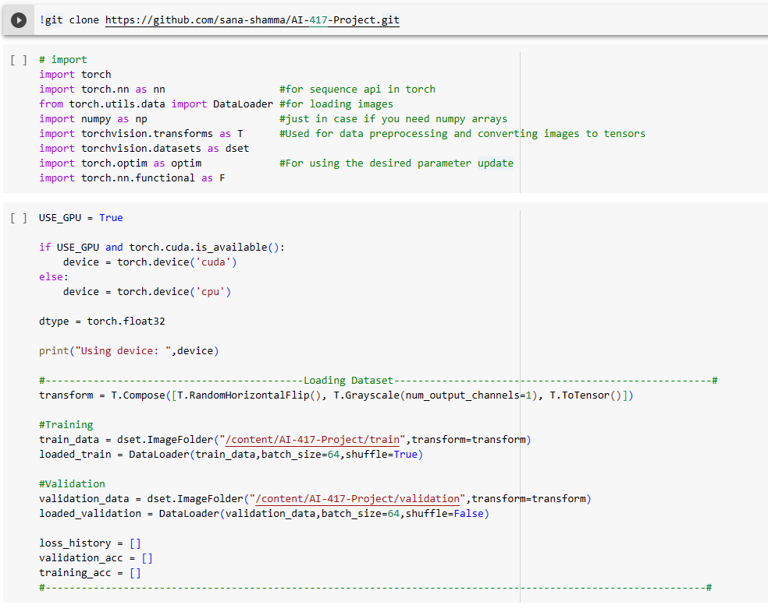

Figure 1 – Loading Dataset

Figure 2 – Validation Function

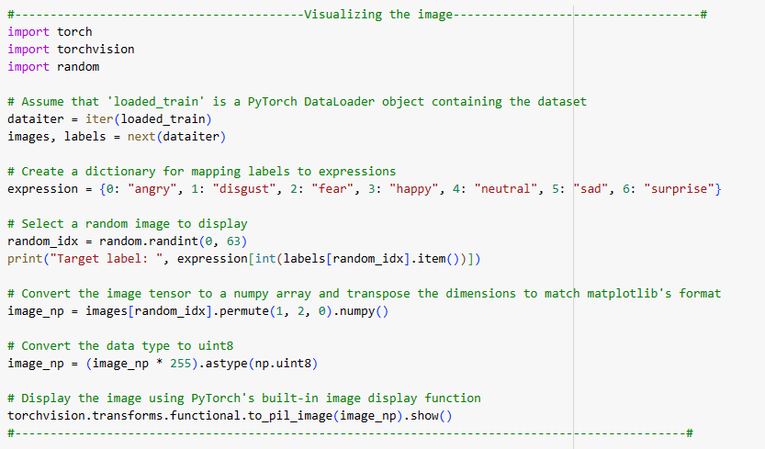

Figure 3 – Visualizing Images

Figure 4 – Training Model

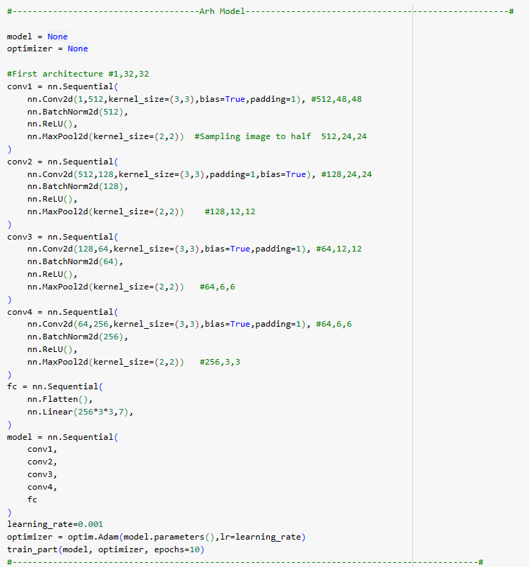

Figure 5 – Model Arch

Figure 6 – Model Accuracy